Social Network Analysis of Misinformation vs Non-Conspiracy Twitter Graphs

Student Information
- Student Name: Ahmed Mohammed Ashri Mourad
- Student ID: 2205229
- Lab Title: Social Network Analysis of WICO Twitter Subgraphs

1. 5G Conspiracy Graph — Full Results
• Number of nodes: 42
• Number of edges: 45
• Average Degree: 1.071
• Graph Density: 0.026
• Average Clustering Coefficient: 0.040
• Modularity (Q): 0.267
• Number of Communities: 13
• Diameter: 3 bot activity
• Radius: 0
• Average Path Length: 1.847826
• Weakly Connected Components: 8
• Strongly Connected Components: 34

Screenshots Needed (5G Graph)
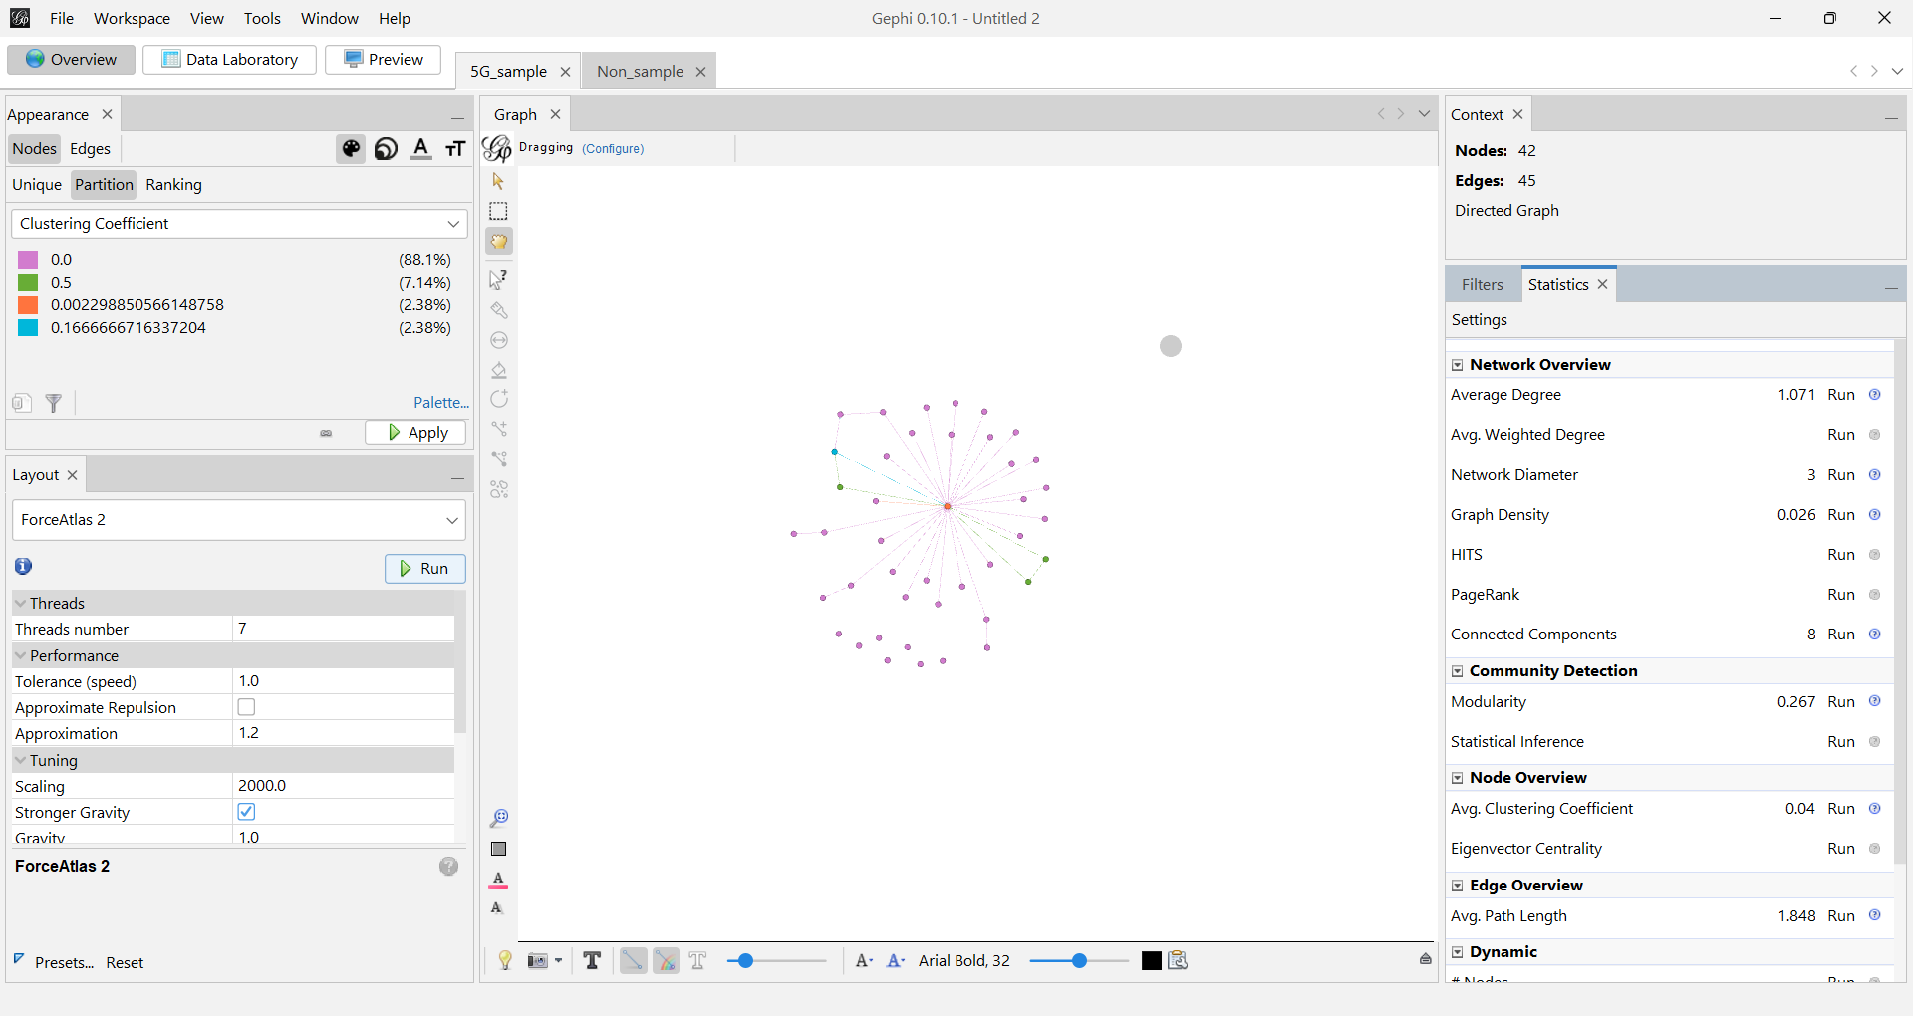
5G Graph Visualization
[ Screenshot — Degree Distribution ]
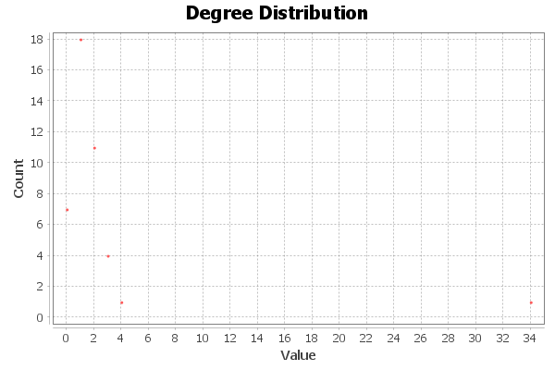
[ Screenshot — Clustering Coefficient Panel ]
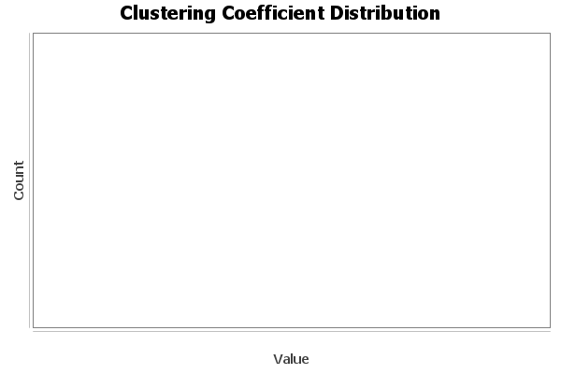
[ Screenshot — Modularity Panel ]
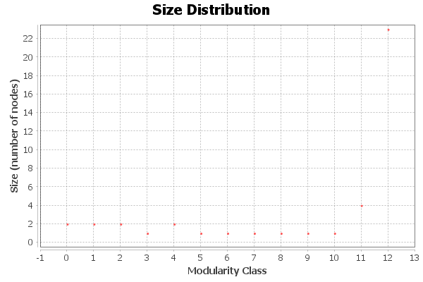
[ Screenshot — Path Length / Centrality Panel ]
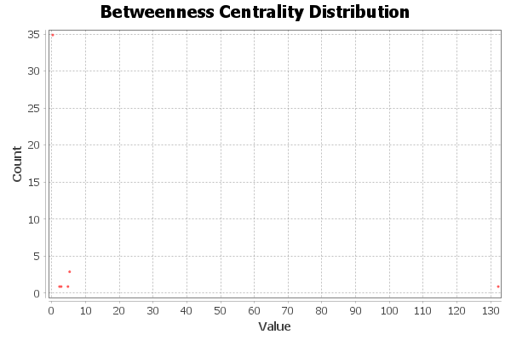
[ Screenshot — Connected Components Panel ]
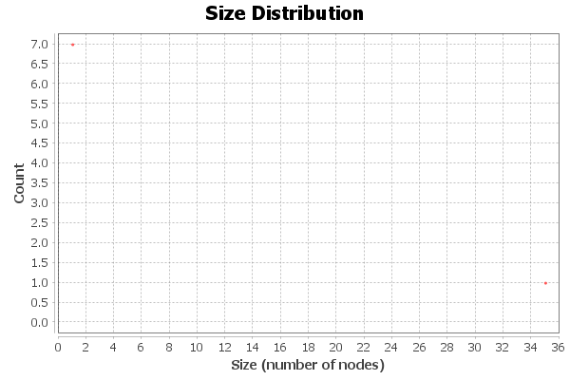

2. Non-Conspiracy Graph — Full Results (Partial)
• Number of nodes: 61
• Number of edges: 62
• Average Degree: 1.016
• Graph Density: 0.017
• Average Clustering Coefficient: 0.049
• Modularity (Q): 0.267
• Number of Communities: 13
• Diameter: 3
• Radius: 0
• Average Path Length: 1.847
• Weakly Connected Components: 5
• Strongly Connected Components: 59

Screenshots Needed (Non-Conspiracy Graph)
[ Screenshot — Non-Conspiracy Graph Visualization ]
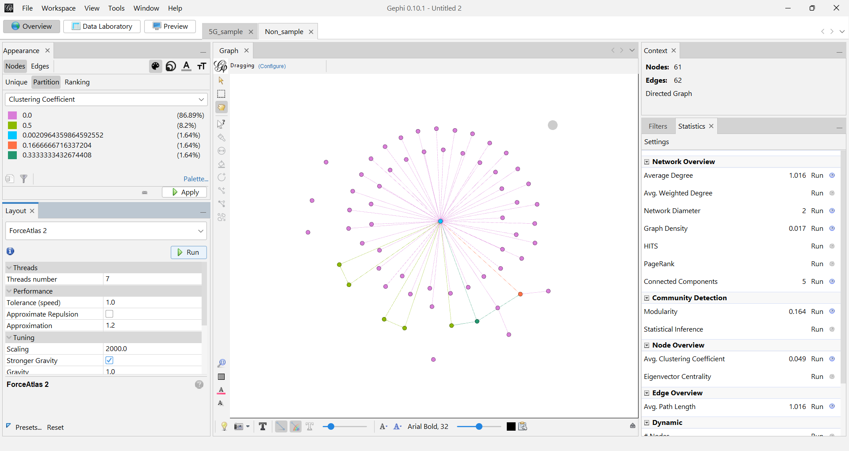
[ Screenshot — Degree Distribution ]
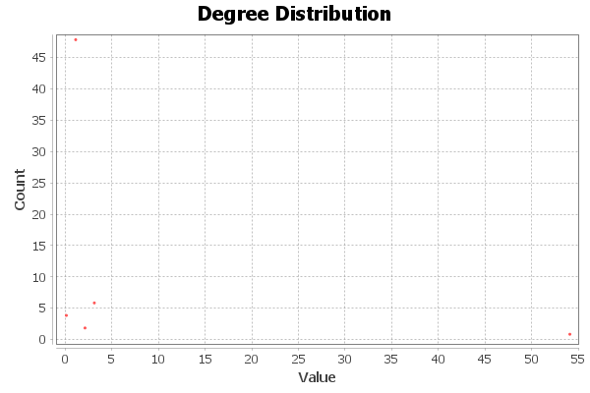
[ Screenshot — Clustering Coefficient Panel ]
[ Screenshot — Modularity Panel ]
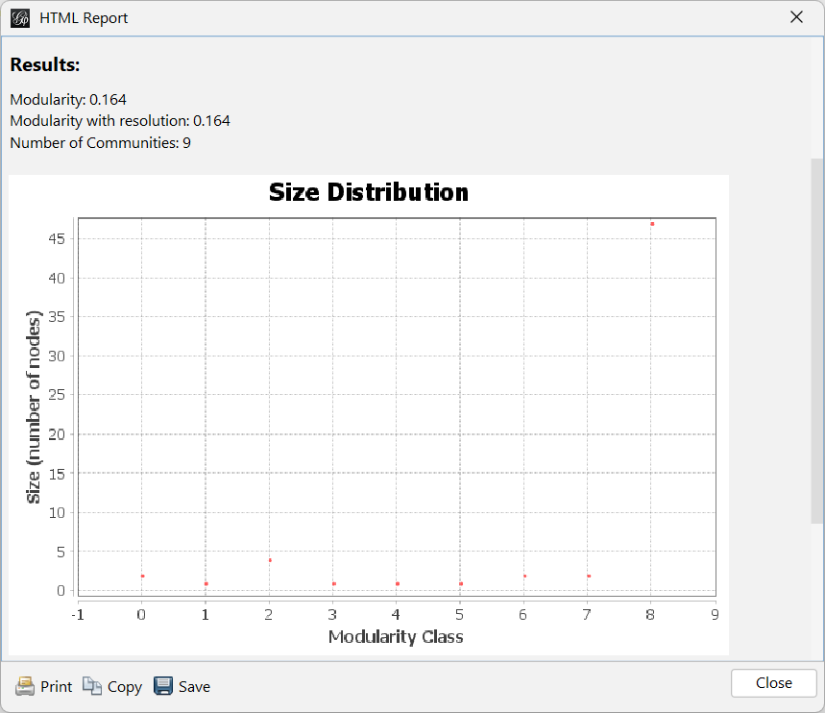
[ Screenshot — Path Length / Centrality Panel ]
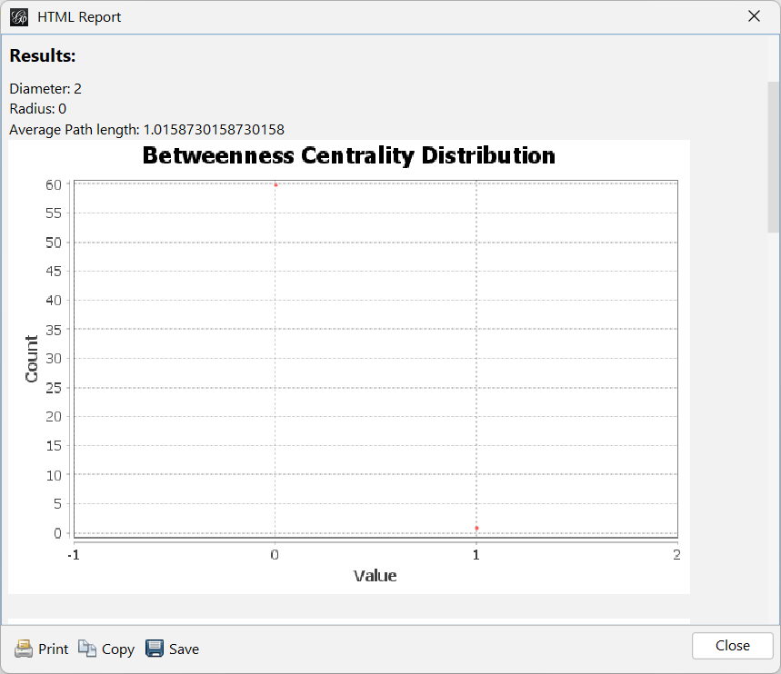
[ Screenshot — Connected Components Panel ]
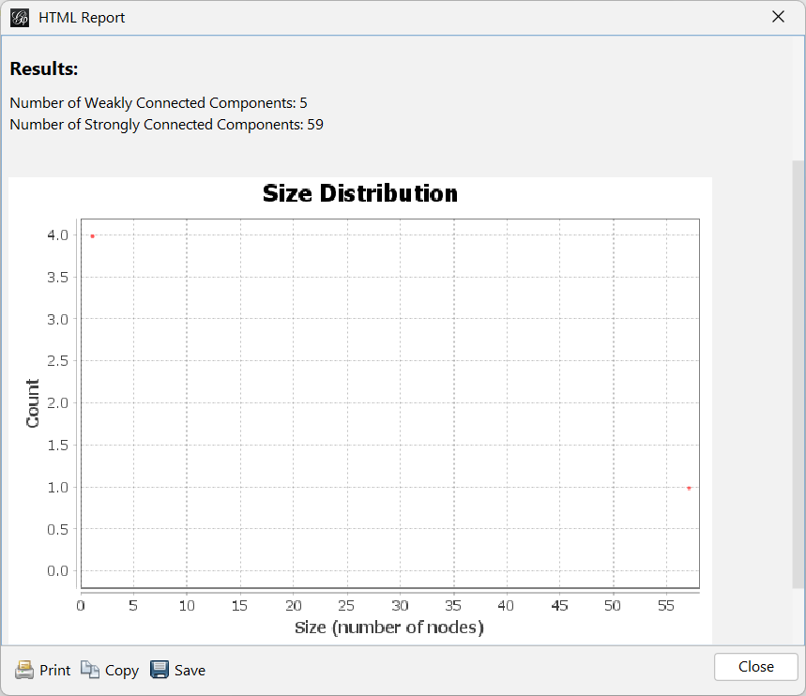

3. Comparative Analysis
• Density: 5G (0.026) is denser than Non-Conspiracy (0.017).
• Average Degree: 5G (1.071) slightly higher than Non-Conspiracy (1.016).
• Clustering: Non-Conspiracy (0.049) > 5G (0.040).
• Components: 5G has more weak components; Non-Conspiracy has more strong ones.
• Modularity: 5G = 0.267; awaiting Non-Conspiracy value.
• Path Length: 5G spreads information faster (1.84 hops).

4. Security Interpretation & Threat Intelligence Findings
• Fake Followers Indicators: Low clustering + high density in 5G → fake follower blocks.
• Bot Activity: Diameter=3, Radius=0 → bot-like structure; low reciprocity.
• Echo Chambers: High density & short paths in 5G → rapid misinformation amplification.
• Influence Operations: Modularity=0.267 → coordinated propagation patterns.
• Coordinated Inauthentic Behavior: Central hubs dominate; fast 2-hop reach.
• Summary: 5G network is high-risk & coordinated; Non-Conspiracy is natural & low-risk.

5. Remaining Items Needed
• Nodes & edges overview for both graphs.
• Modularity report for Non-Conspiracy.
• Distance / Path-length report for Non-Conspiracy.
• Centrality reports (Betweenness, Closeness, Harmonic, Eccentricity).
• All Gephi screenshots.

(You can now edit any part you want — tell me exactly what to add, change, or rewrite.)

